1. **ROTATE RIGHT OPERATION**  
     
   **EXP NO: 19**

**AIM:**To compute rotation of given data in right without carry using 8085 processor. 

**ALGORITHM:**  
1)      Load the base address of the array in HL register pair.  
2)      Move the data from memory location into accumulator.  
3)      Shift right the accumulator content for four times left.  
4)      Store the result in the specified location.

**PROGRAM:**

MVI A,03  
RRC  
RRC  
RRC  
RRC  
STA 2000  
HLT

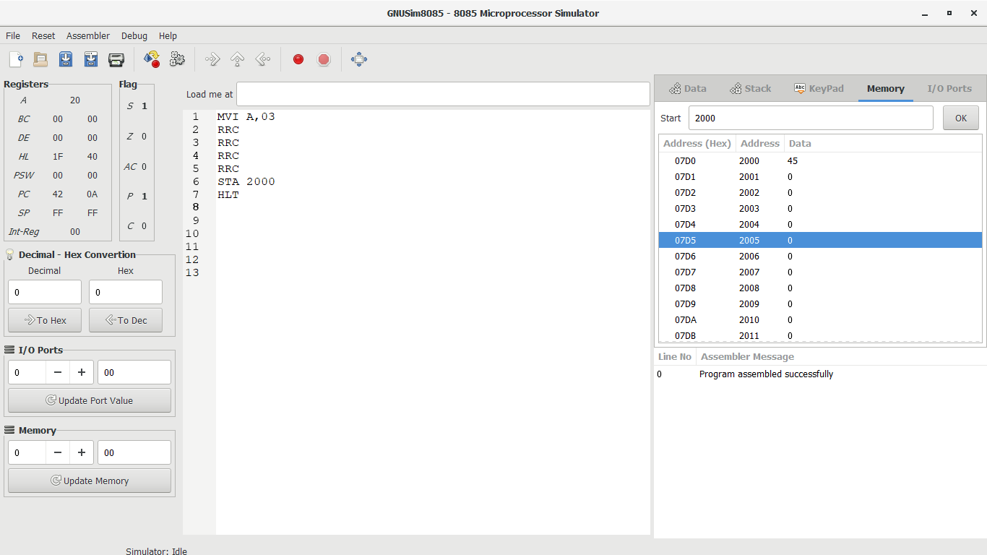**INPUT:**  
  
  
  
  
  
 

**OUTPUT:**  
  
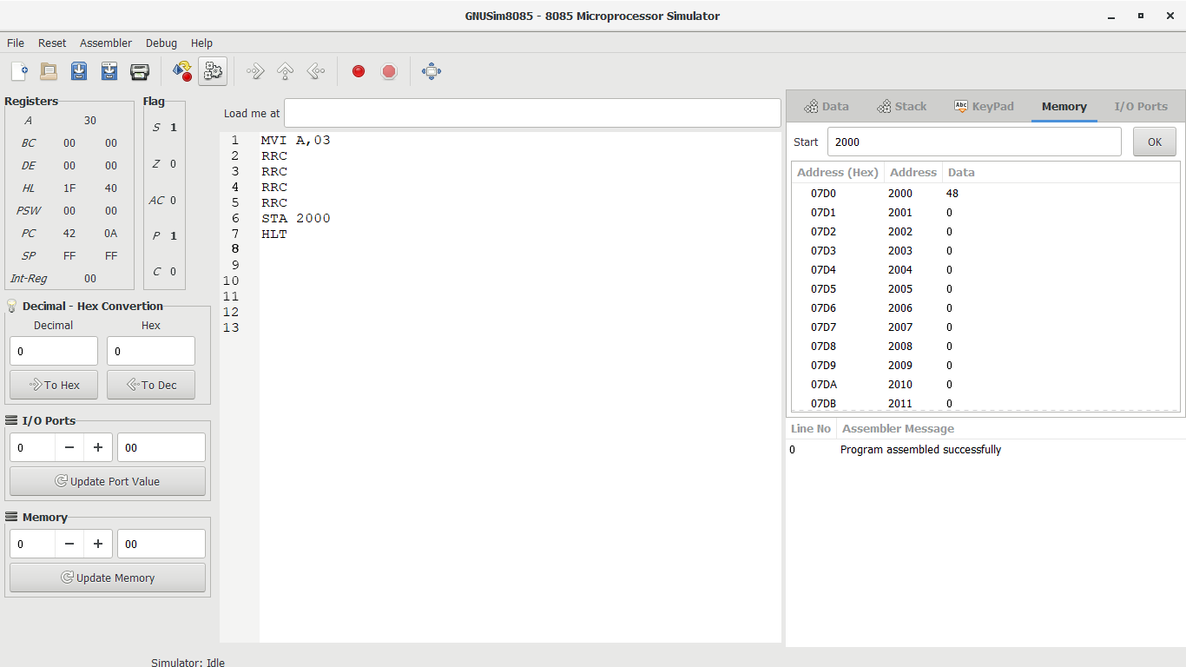  
 

**RESULT:**Thus the program was executed successfully using 8085 processor simulator.